This video explains **OpenStack**, a cloud operating system that helps build private or public cloud infrastructures (2:40).

The video highlights the advantages of cloud computing over on-premise systems (1:01), including:

* **Scalability:** Cloud allows paying only for what is utilized, making scaling up and down easier and faster (1:35).
* **Servers:** Cloud services provide direct access to virtual servers, saving space and money on physical server storage and maintenance (1:48).
* **Data Recovery:** Cloud systems have robust disaster recovery measures for faster data recovery compared to on-premise systems (2:12).

OpenStack is presented as an **Infrastructure as a Service (IaaS)** (3:19), pulling, provisioning, and managing storage, network resources, and computing (3:32). It is built on top of a virtualized environment (4:14) to create a cloud operating system that supports many users for tasks like web hosting, application hosting, and big data (4:18).

Key benefits of OpenStack mentioned in the video include:

* **Cost-effectiveness:** It is free under the Apache 2.0 agreement (4:41).
* **Industry Support:** Developed by NASA, it has strong support and investment from industry leaders like IBM, Red Hat, AMD, and Intel (4:48).
* **Ease of Management:** It offers an easy-to-manage panel for visibility, control, and access to power management tools (5:09).
* **Scalability, Compatibility, and Security:** These are also listed as advantages (5:03).

OpenStack is a collection of software modules, or **projects**, that work together to create and manage cloud infrastructures (0:07-0:13). It provides **Infrastructure as a Service (IaaS)** functionality by pooling, provisioning, and managing compute, storage, and network resources (0:15-0:21). OpenStack is an open-source alternative to cloud platforms like AWS and Azure (0:22-0:31).

Organizations use OpenStack to form a **cloud operating system** on top of a virtualized environment, broadening their pool of computing resources for various tasks such as web hosting, application hosting, or big data (0:40-1:03). Enterprises can select specific software components (projects) to build out the features of their cloud, typically starting with central components like compute, VM images, networking, storage, identity management, and resource management (1:05-1:24).

OpenStack offers several benefits (1:26-1:44):

* **Affordability:** It's freely available under the Apache 2.0 license (1:30-1:32).
* **Reliability:** It has almost a decade of development and use (1:35-1:38).
* **Vendor neutrality:** Its open-source nature helps businesses avoid vendor lock-in (1:40-1:44).

However, there are also drawbacks to consider (1:46-2:06):

* **Complexity:** It requires IT staff with significant knowledge of the platform (1:48-1:53).
* **Support:** It relies on the open-source community as it's not owned by a single vendor (1:55-2:00).
* **Consistency:** The component suite is constantly changing with additions and depreciations (2:01-2:06).

Adopting OpenStack is a process that requires time, financial investment, and support from upper management (2:07-2:15).

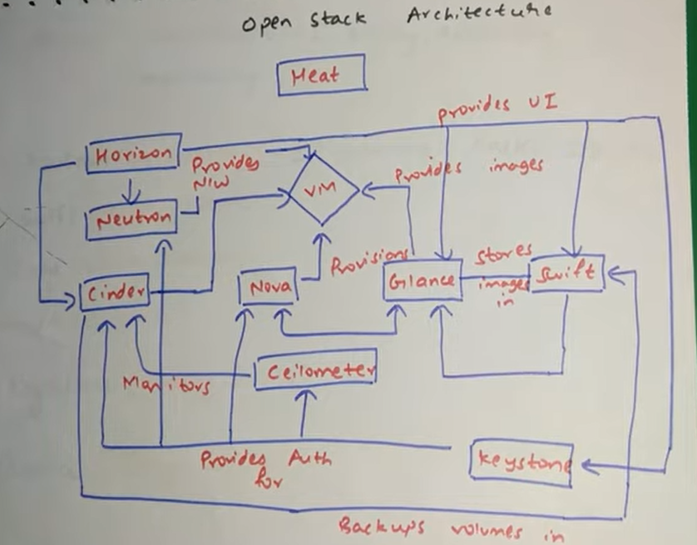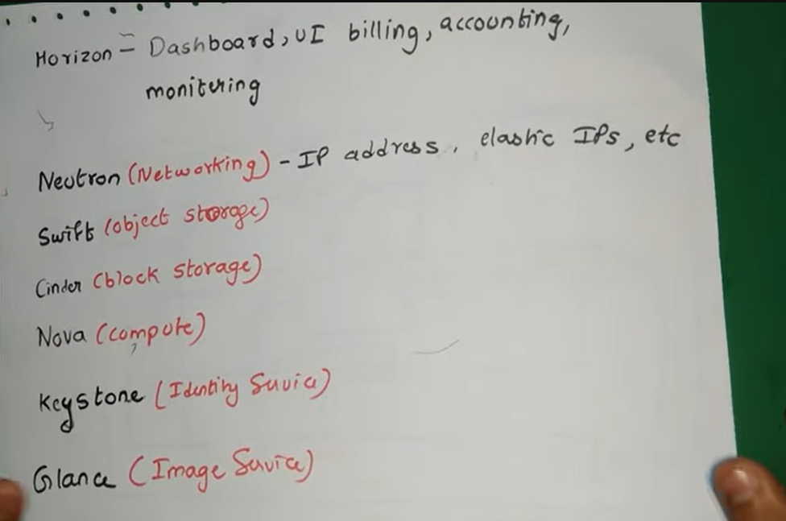The video explains that **OpenStack is an open-source framework for delivering cloud-based IaaS** (Infrastructure as a Service) (0:06). It provides applications with API access to cloud services and is best suited for cloud-native applications (0:15). As a cloud operating system, OpenStack controls large pools of compute, networking, image storage, and other resources within a data center (0:29).

However, OpenStack itself does not provide the virtual infrastructure or most cloud management functionalities like monitoring, troubleshooting, policies, and governance (0:46). This is where **VMware Integrated OpenStack** comes in (0:55). It utilizes VMware's software-defined data center (SDDC) technology to provide the infrastructure, with familiar tools like vSphere, NSX, vSAN, and vCenter interoperating seamlessly with OpenStack (0:57-1:11). This integration simplifies installation and offers optimized management through vRealize operations, log insight, and automation (1:21-1:28). Ultimately, VMware Integrated OpenStack allows IT administrators to easily deploy and manage a production-grade OpenStack cloud on a stable and feature-rich VMware platform (1:33-1:40).

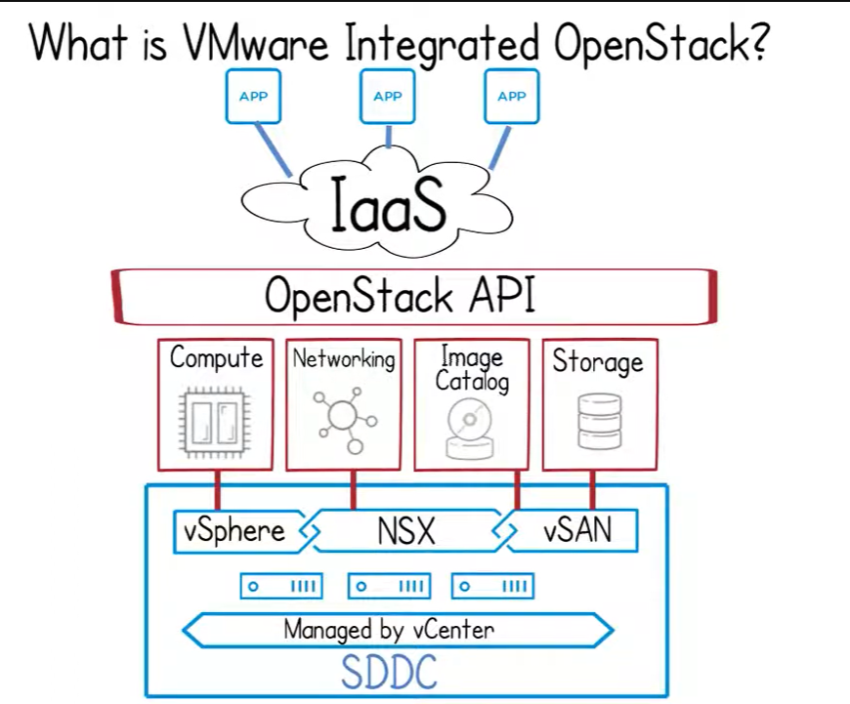This video provides a simplified explanation of **OpenStack components** by relating them to the components needed to build a physical or virtual machine (0:28).

Here are the core OpenStack components and their functions:

* **Nova** (0:46): Represents the compute resources like CPU, RAM, and disk, similar to the hardware of a machine.
* **Glance** (0:51): Corresponds to the operating system or VM image.
* **Neutron** (0:57): Handles the network connectivity for the virtual machine.
* **Cinder** (1:03): Provides external hard disk storage for additional space.
* **Keystone** (1:11): Manages users and accounting within OpenStack.
* **Horizon Dashboard** (1:17): Serves as the control panel to manage all these resources.

When launching a virtual machine on the OpenStack dashboard, you primarily need to provide the VM name, the source (VM image), the flavor (CPU, RAM, and disk configuration), and the network to which the VM will be attached (1:38-1:54).

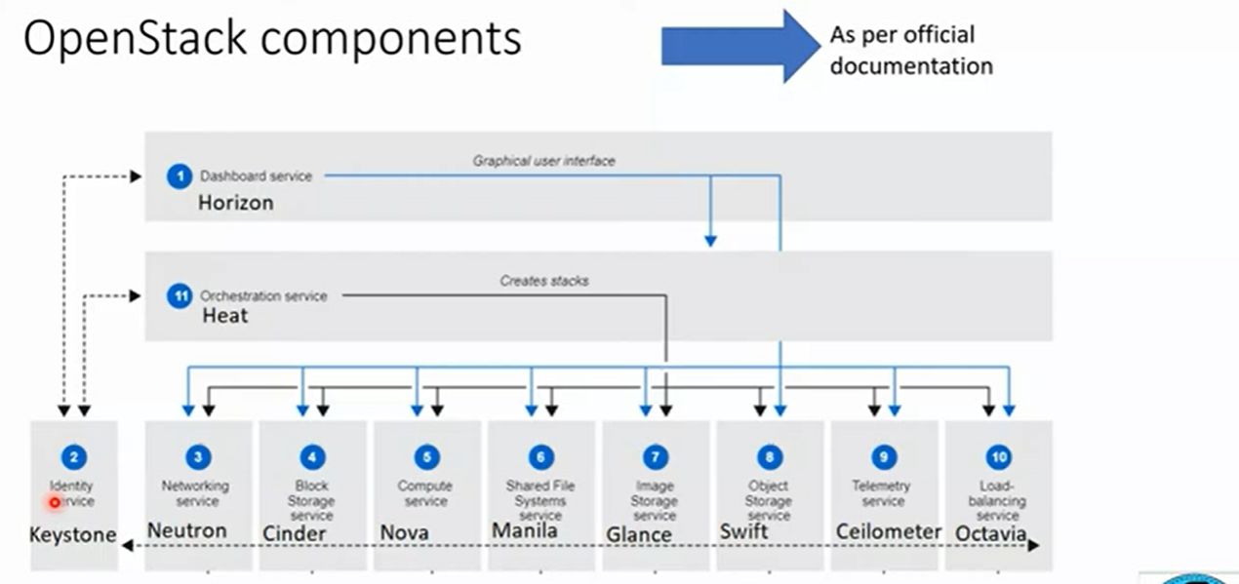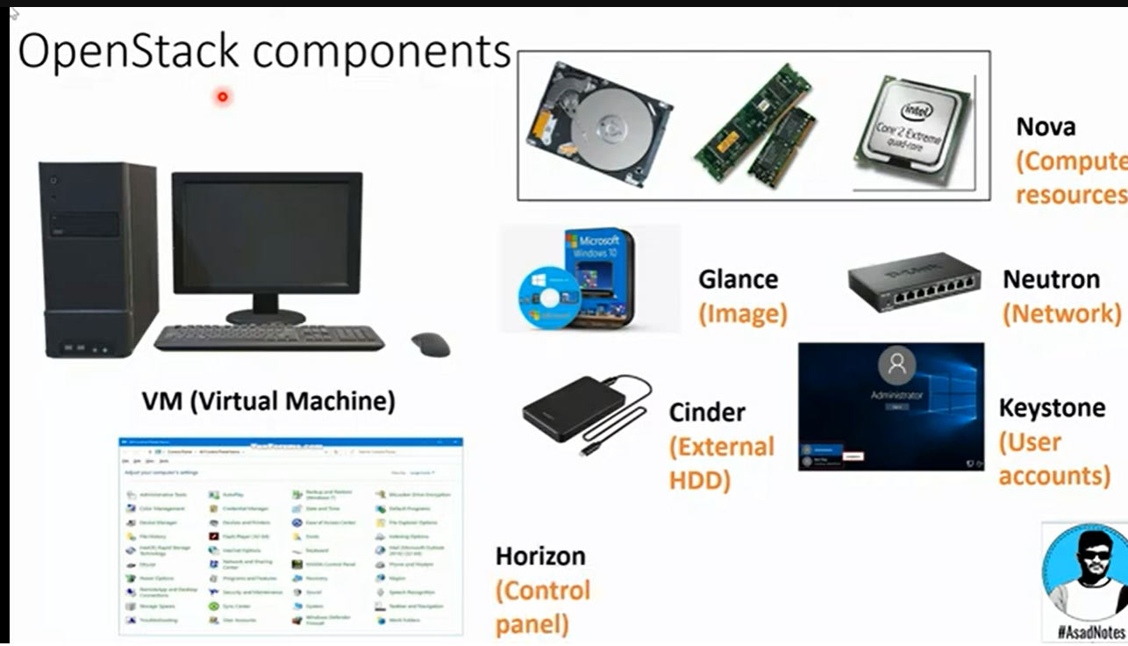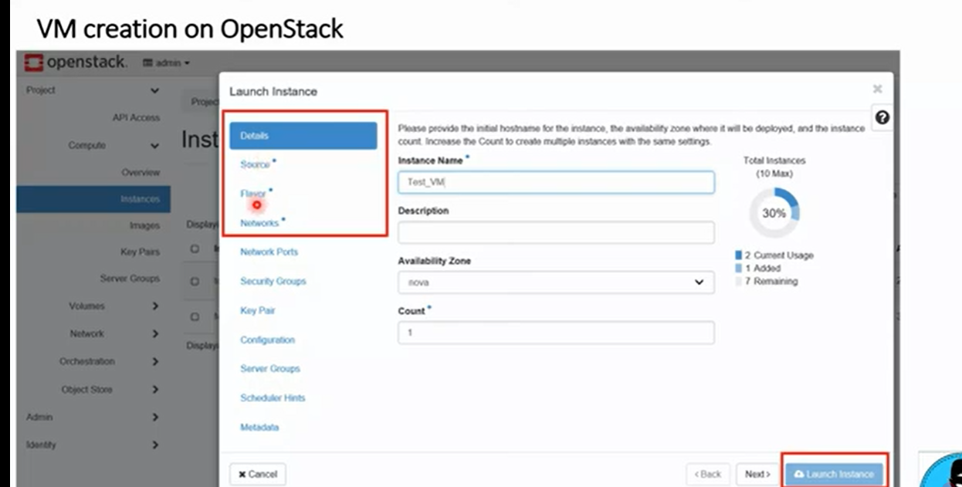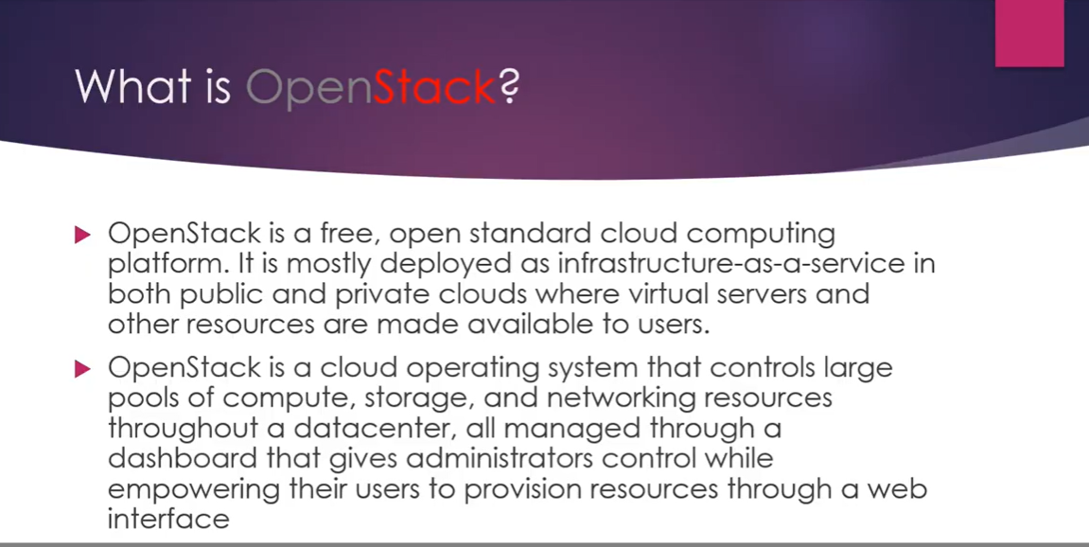This video provides an introduction to **OpenStack**, an open-source cloud computing platform (0:05).

Here's a summary of the key points:

* **What is OpenStack?**
  + It is a free, open-source cloud management software program (0:07-0:16).
  + It is primarily deployed as Infrastructure as a Service (IaaS) (0:17-0:20).
  + It is used in public and private clouds to manage virtual servers and other resources (0:27-0:34).
  + OpenStack helps control large pools of computing, networking, and storage resources at a data center level (0:36-0:49, 0:55-1:09).
* **Origin and Technical Details**
  + Originally developed by Rackspace Hosting and NASA (1:14-1:19).
  + Its initial release was on October 21, 2010 (1:21-1:26).
  + It is written in Python (1:26-1:29).
  + Its official website is openstack.org (1:34-1:36).
* **Core Services (1:49-1:57)**
  + **Nova:** Manages a large number of virtual machines (2:06-2:15).
  + **Swift:** Provides object storage, similar to Amazon S3 (2:17-2:25).
  + **Cinder:** Manages block storage and physical storage devices (2:27-2:39).
  + **Neutron:** Provides networking services (2:41-2:44).
  + **Horizon:** The dashboard or graphical user interface for OpenStack (2:47-2:57).
  + **Keystone:** An identity service for authentication and authorization (2:59-3:08).
  + **Glance:** Provides image services, allowing users to store and discover virtual machine images (3:28-3:42).
  + **Ceilometer:** Offers metering services to track cloud resource usage on an individual basis (3:45-4:03).
  + **Heat:** Allows developers to define cloud application requirements and necessary resources in a file (4:03-4:42).
* **Automation Capabilities**
  + OpenStack can automate computing, storage, backup and recovery, networking, data analytics, security, identity and compliance management, monitoring, metering, application services, and development deployments (6:49-7:07).
* **Industries Using OpenStack**
  + Major companies like Walmart, Snapdeal, AT&T, Harvard University, Comcast, and Verizon utilize OpenStack (7:25-7:42).
  + It is widely used in Information Technology (IT), telecommunications, finance, government, manufacturing, and academic research (8:11-8:23).
* **Deployment Models**
  + Most commonly used for **on-premise private clouds** (8:58-9:11).
  + Also used in public and hybrid clouds (9:14-9:16).
* **Reasons for Choosing OpenStack**
  + Increases operational efficiency (9:24-9:37).
  + Offers excellent flexibility and innovation (9:37-9:42).

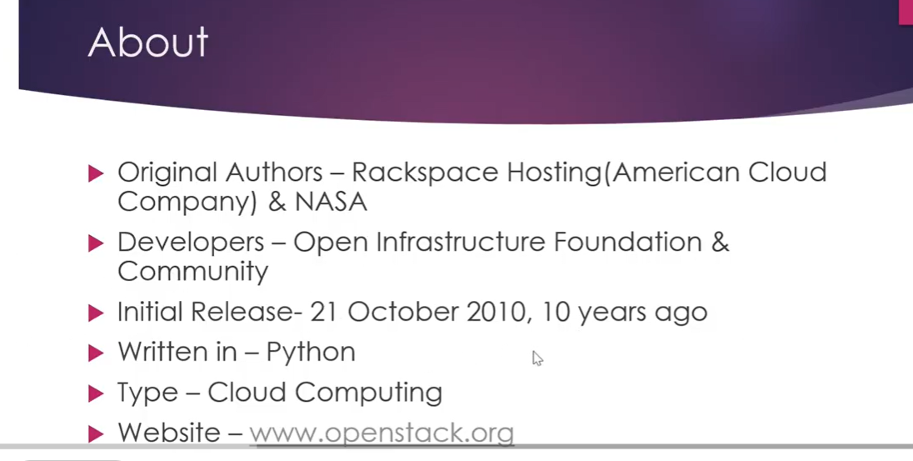m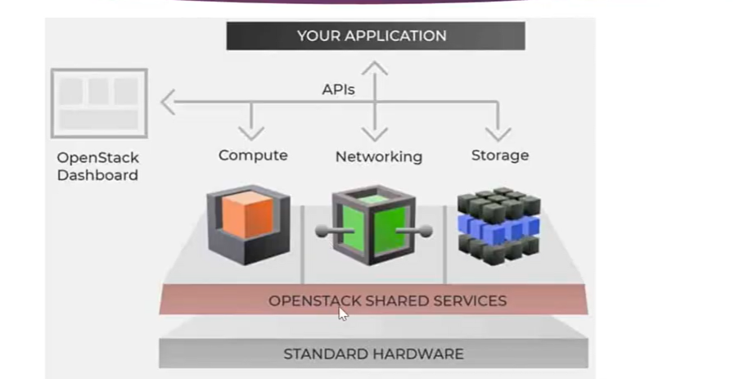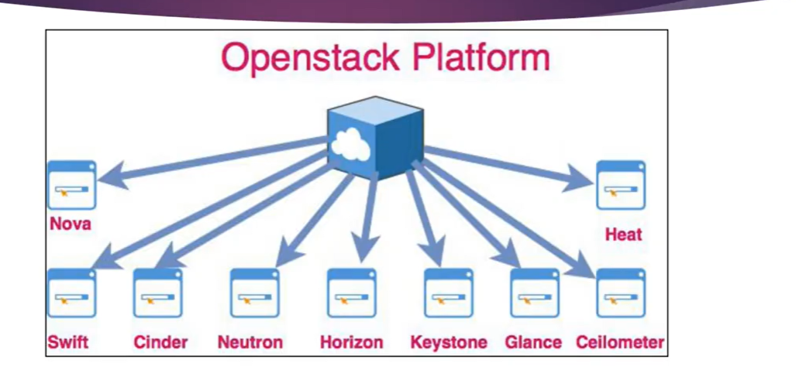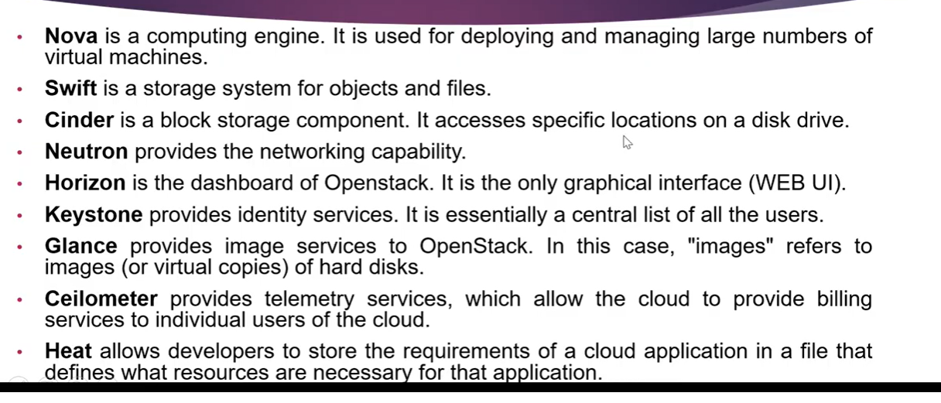m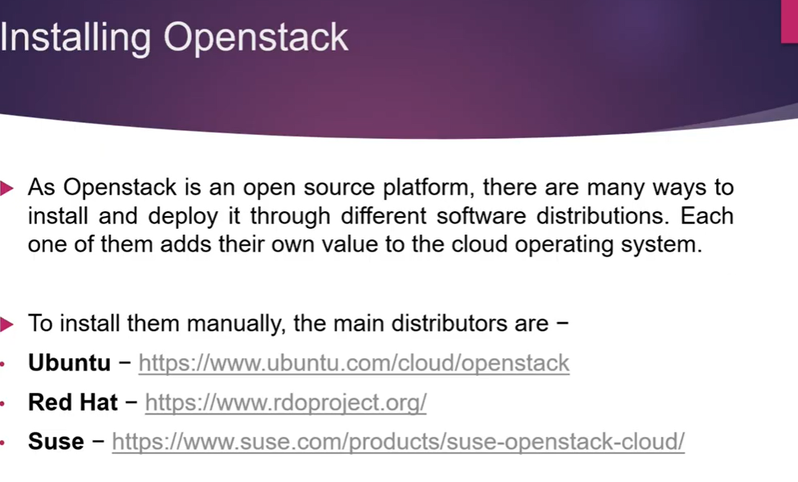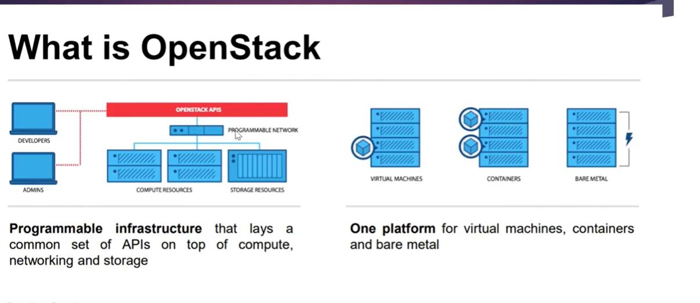m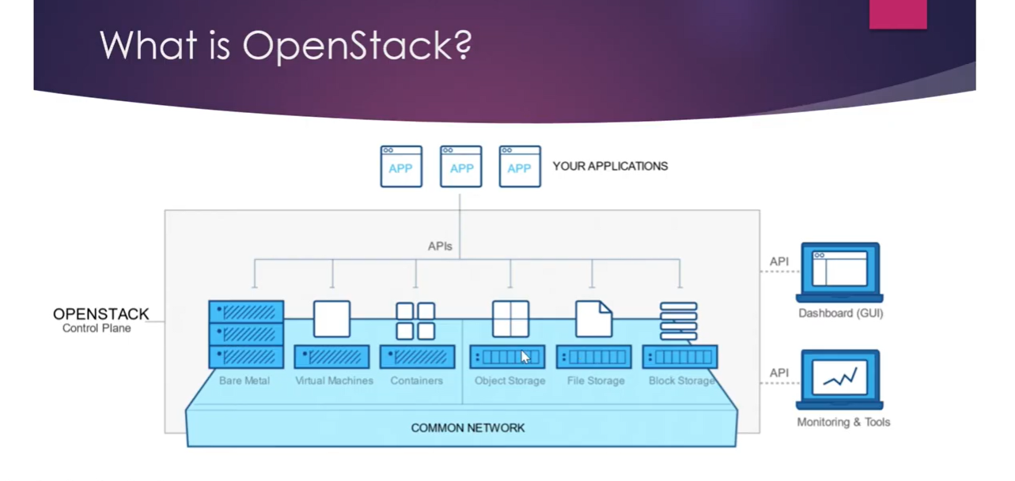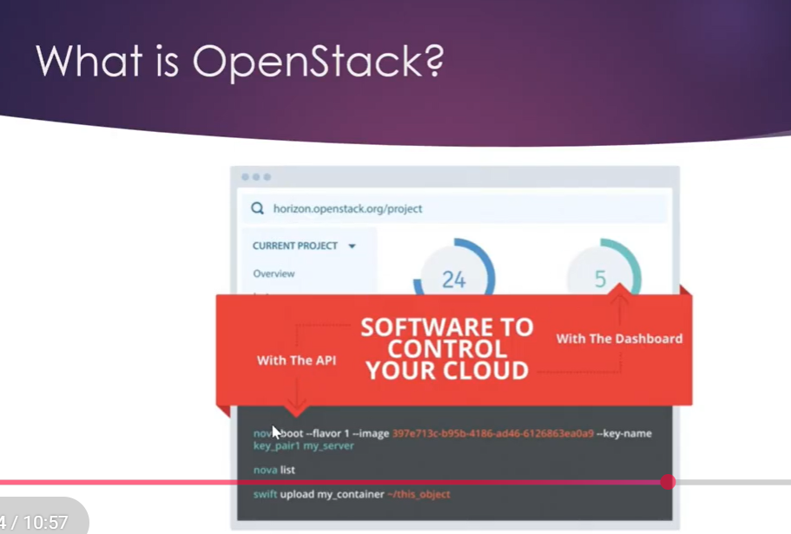m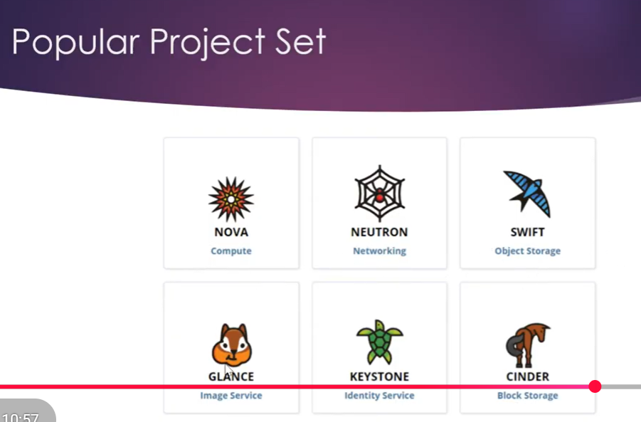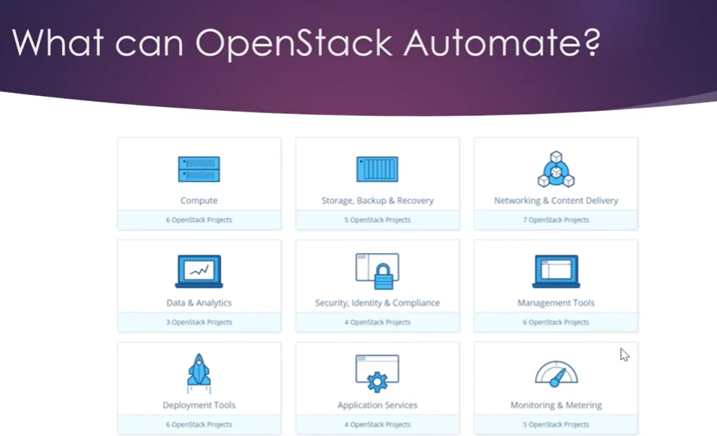m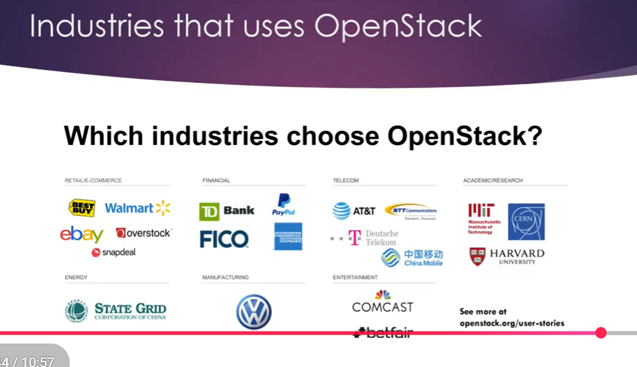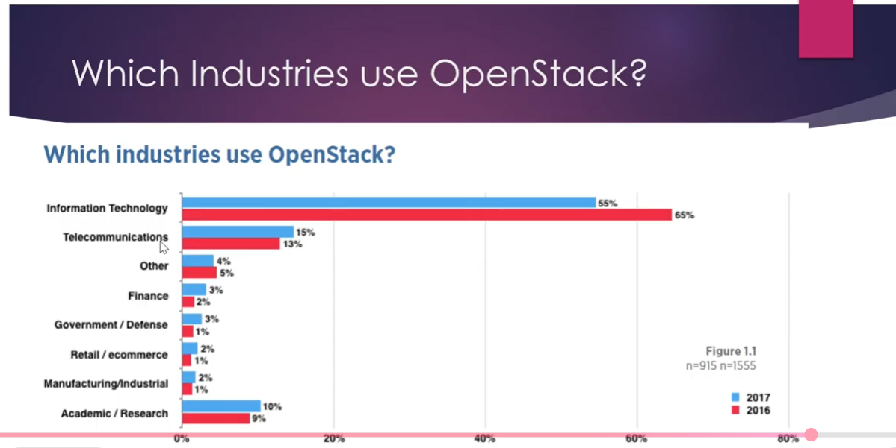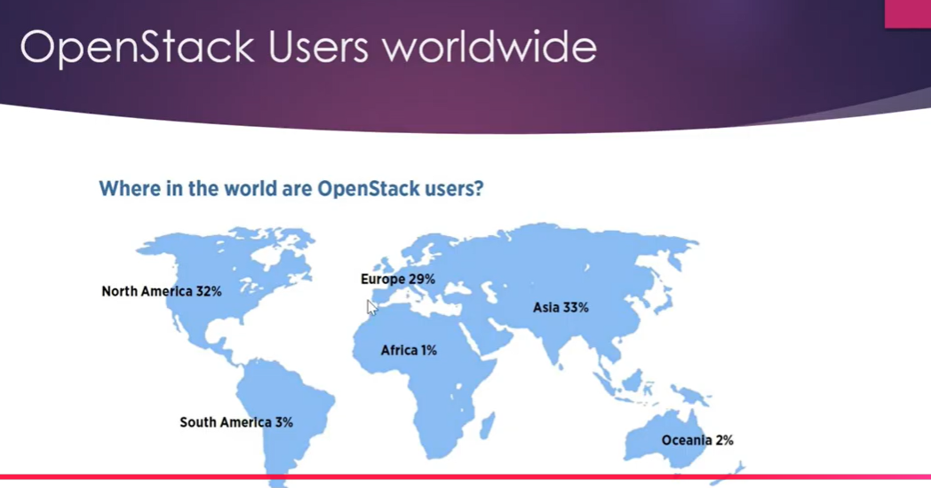m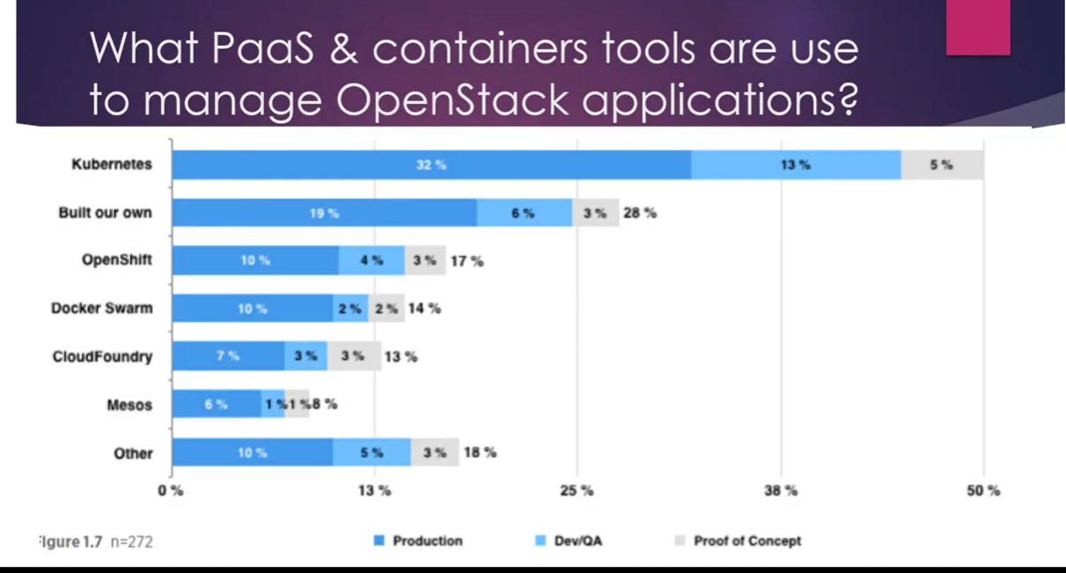m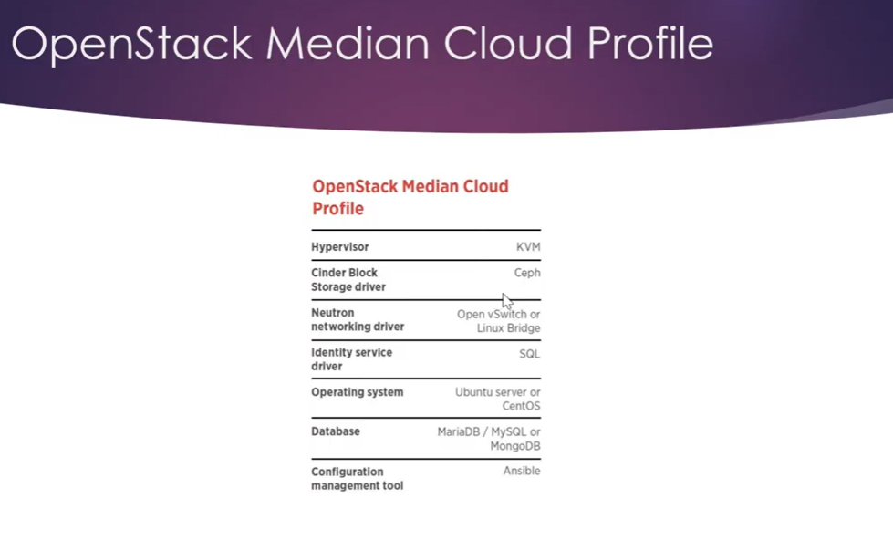

Here’s a **complete, in-depth explanation of OpenStack** for **Parallel and Distributed Computing**, covering architecture, services, examples, and practical use cases.

**OpenStack: Parallel & Distributed Computing**

**1. Definition of OpenStack**

**OpenStack** is an **open-source cloud computing platform** that provides **infrastructure as a service (IaaS)**. It allows organizations to create **private and public clouds**, providing virtualized computing, storage, and networking resources over a distributed system.

**Exam-ready one-line definition:**

**OpenStack is an open-source cloud platform that enables distributed and parallel computing by managing compute, storage, and networking resources in a scalable and virtualized environment.**

**2. Why OpenStack is Needed**

Traditional computing challenges:

* Limited hardware
* Expensive scaling
* Resource underutilization
* Difficult multi-tenant management

OpenStack solves this by:

* Providing **on-demand virtual machines**
* Enabling **parallel execution of tasks**
* Offering **distributed resource management**
* Supporting **multi-tenant environments**

**3. OpenStack Use in Parallel & Distributed Computing**

* **Parallel Computing:** Run multiple virtual machines (VMs) or containers simultaneously across nodes for computational tasks.
* **Distributed Computing:** Deploy services across multiple nodes and data centers; manage workloads with fault tolerance and high availability.
* **High-Performance Computing (HPC):** Integrates with clusters and batch processing frameworks like SLURM or Kubernetes.

**4. OpenStack Architecture**

OpenStack has a **modular, layered architecture**.

**4.1 Layers**

| **Layer** | **Function** |
| --- | --- |
| **Compute** | Virtual machines / bare-metal nodes (Nova) |
| **Storage** | Block storage (Cinder) & object storage (Swift) |
| **Networking** | Software-defined networking (Neutron) |
| **Identity & Access** | Authentication and authorization (Keystone) |
| **Dashboard** | Web-based UI (Horizon) |
| **Image Service** | VM image management (Glance) |
| **Orchestration** | Automation & deployment (Heat) |
| **Telemetry / Monitoring** | Collects metrics & logs (Ceilometer) |

**4.2 OpenStack Components & Services**

| **Component** | **Role** |
| --- | --- |
| **Nova** | Manages compute resources (VMs) |
| **Neutron** | Provides virtual networking and IP management |
| **Swift** | Distributed object storage for large data |
| **Cinder** | Block storage for VMs |
| **Keystone** | Identity management (users, roles, permissions) |
| **Glance** | Stores VM images and snapshots |
| **Horizon** | Web dashboard for managing OpenStack |
| **Heat** | Orchestration engine for automating deployments |
| **Ceilometer** | Monitoring, metering, and telemetry |

**5. How OpenStack Supports Parallel & Distributed Computing**

**Parallel Computing Example**

* Run multiple VMs on different compute nodes for tasks like:
  + Scientific simulations
  + Data analysis
  + Batch processing

**Steps:**

1. User requests 10 VMs via Nova.
2. OpenStack schedules VMs on available compute nodes.
3. Tasks execute in parallel on these VMs.
4. Results are collected and merged.

**Distributed Computing Example**

* Deploying a distributed web service or database across multiple nodes:
  + Swift stores replicated data across nodes.
  + Nova deploys VMs on multiple servers.
  + Neutron connects nodes with private networks.
  + Load balancer distributes requests.

**Result:** A fault-tolerant, scalable distributed system.

**6. Example Scenario: Distributed Data Processing**

1. **Data Storage:** Store large datasets in Swift.
2. **Compute Nodes:** Launch multiple Nova instances to process the data.
3. **Networking:** Neutron ensures VMs can communicate securely.
4. **Orchestration:** Heat automates deployment of processing pipelines.
5. **Monitoring:** Ceilometer tracks performance metrics and usage.

**7. Advantages of OpenStack**

* **Open-source:** Free, community-supported
* **Scalable:** Easily add nodes to expand resources
* **Modular:** Components can be used independently
* **Flexible:** Supports private, public, or hybrid clouds
* **Distributed & Parallel:** Supports VMs and services across multiple nodes
* **Multi-tenant:** Supports multiple users/projects

**8. Limitations of OpenStack**

* Complex to install and maintain
* High learning curve
* Requires skilled administrators
* Performance may depend on hardware and network setup

**9. OpenStack vs AWS vs Globus vs Condor**

| **Feature** | **OpenStack** | **AWS** | **Globus** | **Condor** |
| --- | --- | --- | --- | --- |
| Type | Private/Public Cloud | Public Cloud | Middleware | Job Scheduler |
| Parallel Computing | VMs, Containers | EC2, Lambda | Task distribution | Independent jobs |
| Distributed Computing | Across nodes | Across regions & zones | Across grids | Across idle nodes |
| Storage | Cinder, Swift | S3, EBS | GridFTP | Local/NFS |
| Cost | Free, hardware cost | Pay-as-you-go | Free / Academic | Free / Open-source |
| Security | Keystone, Firewall | IAM, Encryption | GSI | Authentication & Job Permissions |

**10. Real-World Use Cases**

* Private cloud for universities
* Scientific research computing clusters
* Big Data processing
* Multi-node simulations
* Parallel batch job execution

**11. Exam-Oriented Summary**

**Keywords:**

* IaaS
* Nova, Neutron, Swift, Cinder
* Parallel & Distributed computing
* Multi-tenant
* Orchestration

**One-Paragraph Answer:**

OpenStack is an open-source cloud platform that provides virtualized compute, storage, and networking resources for parallel and distributed computing. It allows users to deploy multiple VMs across nodes, manage data storage with Swift and Cinder, create virtual networks with Neutron, and automate deployments with Heat, enabling scalable, fault-tolerant, and multi-tenant cloud environments.

If you want, I can now make a **full diagram comparing OpenStack, AWS, Globus, and Condor architectures together**, which is extremely helpful for exams and quick revision.

Do you want me to do that?